**1. Introduction to Proposed System**

**1.1 Problem Definition:**

The real estate market in Pune is highly dynamic, with house prices fluctuating based on various factors like location, area, number of bedrooms, and amenities. For buyers and sellers, determining the accurate market value of a property is often challenging without relying on expert opinions or time-consuming manual research. The problem is further compounded when individuals lack access to reliable datasets and predictive tools.

The Pune house price prediction system aims to address this challenge by leveraging machine learning algorithms to analyze historical real estate data and predict house prices with high accuracy. This system provides an efficient and user-friendly platform for users to input property details and receive precise price predictions. It assists buyers in planning their budgets and sellers in pricing their properties competitively.

**1.2 System Overview:**

The proposed system is a web-based application built using the Flask framework and Python programming language. It integrates a machine learning model trained on Pune’s real estate data to provide house price predictions.

Users interact with the system through a graphical user interface (GUI), where they input property details such as location, total area, number of bedrooms, and additional features. These inputs are processed by the backend server, which uses the trained model to generate the predicted price. The prediction is then displayed on the GUI.

The application is modular, consisting of data preprocessing, model training, user input handling, and result display modules. This modular architecture makes the system easy to update and maintain.

**1.3 Project Functionalities with Module Specification:**

* Data Preprocessing and Model Training Module:
* Cleans and preprocesses real estate data, removing anomalies and missing values.
* Splits the data into training and testing sets to ensure accurate model evaluation.
* Trains the machine learning model using algorithms like Linear Regression or Random Forest.
* User Interface Module:
* Provides a simple and intuitive GUI for users to input property details such as location, area, and amenities.
* Prediction Module:
* Processes user inputs in real-time, feeds them to the trained model, and computes the predicted price.
* Result Display Module:
* Outputs the predicted price in a user-friendly format on the GUI.
* Displays additional insights, such as average prices in the given location or comparison with market trends.

**1.4 Operating Environment (H/W & S/W Requirement Specification):**

**Hardware Requirements:**

Minimum:

4GB RAM

2GHz Dual-Core Processor

500MB free disk space

Recommended:

8GB RAM

2.5GHz Quad-Core Processor

SSD for faster performance

Software Requirements:

Programming Language: Python 3.9 or above

Framework: Flask (for web application development)

**Libraries:** Scikit-learn (machine learning), Pandas (data processing), Numpy (numerical computation), Matplotlib/Seaborn (visualization)

**Database:** SQLite or CSV files for storing the dataset

**Web Technologies:** HTML/CSS/JavaScript for frontend GUI

**Operating System:** Linux (preferred) or Windows

**2. Overview of the Proposed System**

**2.1 Proposed System:**

The proposed system is a web-based application aimed at predicting house prices in Pune using machine learning techniques. This system provides a platform where users can input property details such as location, size (in square feet), number of bedrooms, and other features, and receive an estimated house price. The predictions are based on a trained machine learning model that analyzes historical real estate data to deliver accurate results.

The system is developed to address the complexities of the real estate market, offering a solution that saves time, reduces dependency on manual methods, and ensures precision. With its modular architecture, the system is scalable and can easily adapt to include additional features such as comparisons with market averages, historical price trends, or location-based analysis.

**2.2 Objectives of the System:**

* The main goals of the system are:
* To create a reliable tool for predicting house prices in Pune using advanced data-driven methods.
* To simplify the decision-making process for buyers and sellers by providing quick and accurate price estimates.
* To eliminate the need for manual research or expensive consultations with real estate experts.
* To provide insights into property values, making the real estate market more accessible to non-experts.
* To establish a user-friendly platform with minimal learning curves for users of varying technical skills.

**2.3 Feasibility Study:**

To ensure the success and practical implementation of the system, a feasibility analysis was conducted across technical, operational, economic, and legal domains.

**Technical Feasibility:**

The system is technically viable as it uses well-established technologies such as Python, Flask, Scikit-learn, Pandas, and Numpy. These tools are widely supported and reliable for implementing machine learning models and web applications. Additionally, the system can run on minimal hardware requirements, ensuring accessibility.

**Operational Feasibility:**

The system is user-friendly and does not require specialized skills to operate. Users can interact with the application through a graphical user interface (GUI) designed with simplicity and clarity. The prediction process is automated, ensuring a seamless user experience.

**Economic Feasibility:**

The system uses open-source tools and frameworks, significantly reducing development and deployment costs. Hardware requirements are minimal, and there is no need for high-end infrastructure, making the system cost-effective for both developers and users.

**Legal Feasibility:**

The system adheres to legal and ethical guidelines, ensuring that the data used for training the machine learning model is sourced responsibly. It does not breach user privacy or intellectual property rights, making it legally compliant.

**2.4 User Requirement Specification:**

The system is designed to cater to the following user requirements:

**Input Requirements:**

* Users should be able to input property details such as:
* Location (e.g., neighborhood or locality)
* Total area (in square feet)
* Number of bedrooms and bathrooms
* Additional features like parking, balcony, etc.

**Processing Requirements:**

* The system should handle the inputs and process them using the trained machine learning model in real-time.
* The prediction process should be optimized for performance, providing results quickly.

**Output Requirements:**

* Display the predicted price in a clear and comprehensible format.
* Include additional information such as average property prices in the locality and comparisons with similar properties.

**Compatibility Requirements:**

* The system should be accessible via commonly used web browsers (e.g., Chrome, Firefox) and devices (PCs, laptops, or tablets).

**User Interface Requirements:**

* The GUI should be intuitive and visually appealing, with simple navigation options and input forms.
* This comprehensive overview highlights the proposed system’s vision, goals, feasibility, and user-centric approach. It ensures that the system is practical, efficient, and designed to meet the needs of its target audience effectively

**3. System Analysis & Design**

**3.1 Data Flow Diagram :**

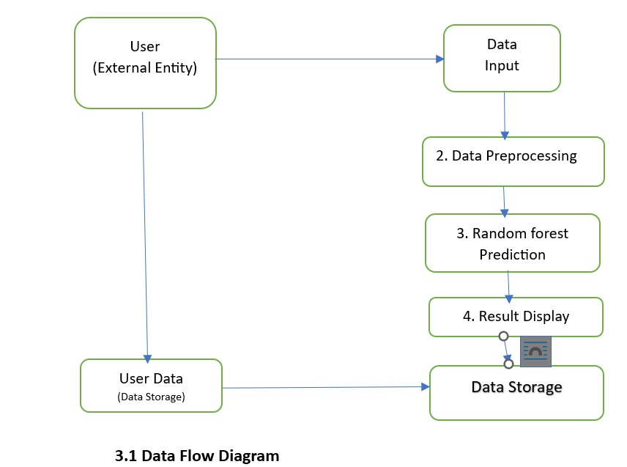

**3.2 Class Diagram**

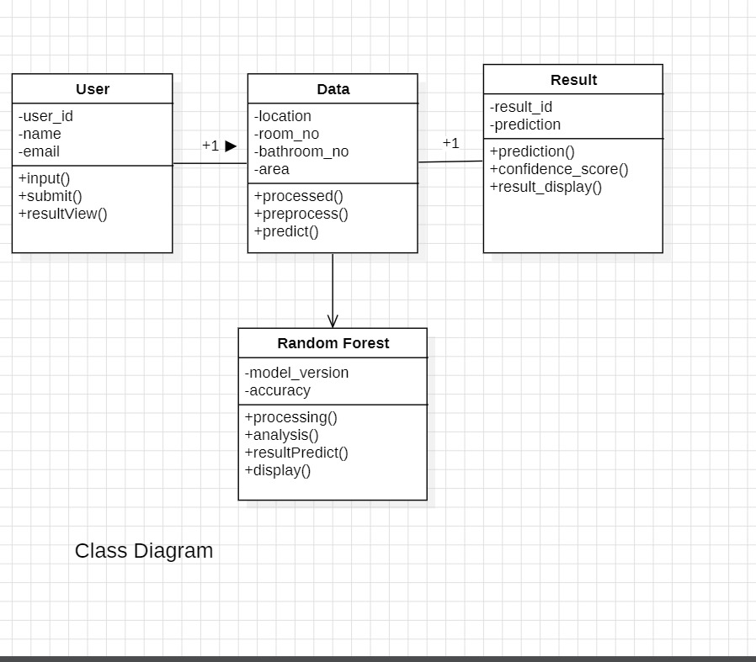

**3.3 Activity Diagram**

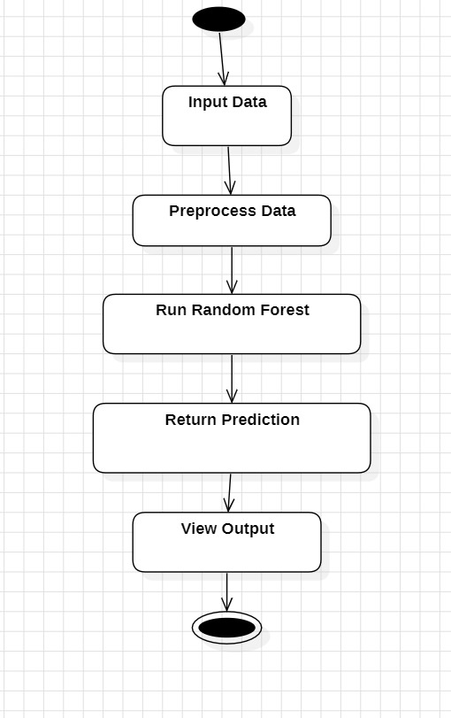

**3.4 Use Case Diagram**

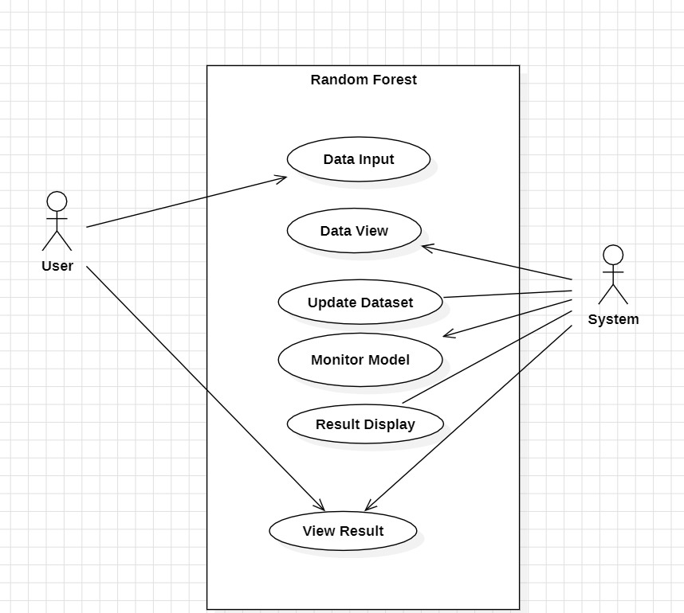

**4. User Manual**

**4.1 Operational Instructions**

The Pune House Price Prediction System provides an easy-to-use interface for users to input property details and view predictions. Follow the steps below for smooth operation:

**Step 1: Start the Application**

* Launch the application by opening your preferred web browser.
* If running locally, enter http://127.0.0.1:5000 in the browser's address bar.
* If hosted on a server, use the provided URL to access the application.

**Step 2: Navigate to the Input Form**

* On the home page, you will see a user-friendly form to enter property details.
* The form includes fields such as:
* Location: Select the area or neighborhood in Pune from a dropdown list.
* Total Area: Enter the total area of the property in square feet (e.g., 1000 sqft).
* Number of Bedrooms: Input the total number of bedrooms.
* Number of Bathrooms: Specify the number of bathrooms.

**Step 3: Submit the Form**

* After filling in the details, click on the "Predict Price" button located below the form.
* The system will process your inputs and use the trained machine learning model to predict the property price.

**Step 4: View Results**

* The predicted price will appear on the next screen.
* The output is displayed in a simple, clear format, e.g., “The estimated price for your property is Rs. 85,00,000.”
* The results may include additional insights such as a comparison with average market trends or visual graphs (if enabled).

**Step 5: Reset or Try Again**

* If you want to calculate the price for another property, click the "Reset" button to clear the input fields.
* Enter new details and click "Predict Price" again for another estimation.

**Step 6: Exit the Application**

* Close the browser to end your session. If hosted locally, stop the Flask server to shut down the application.

**4.2 Input/Output Screens**

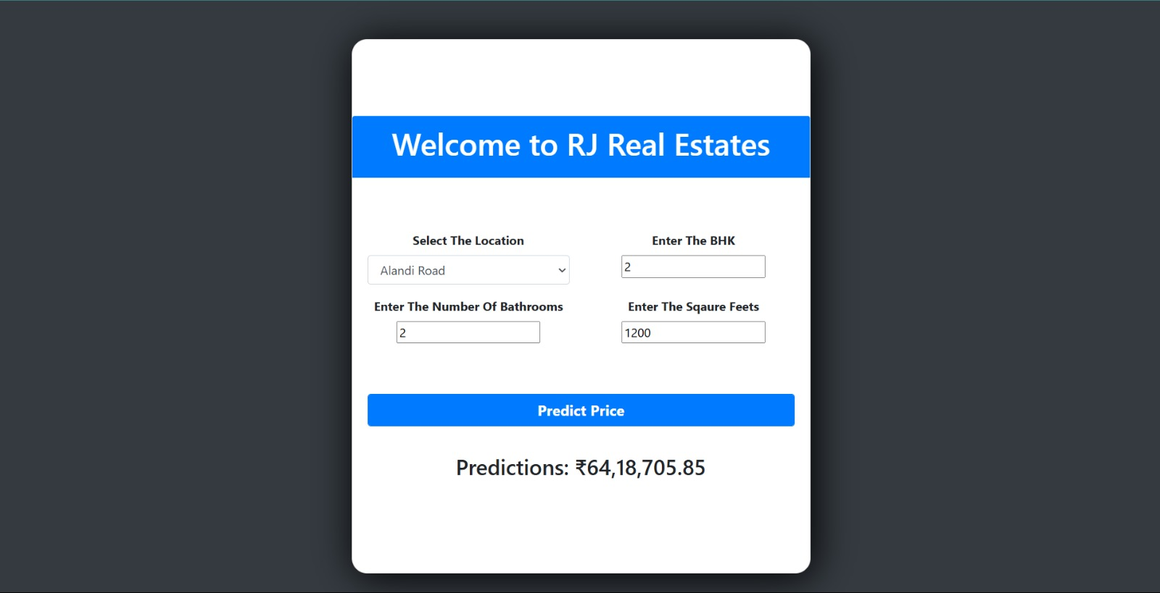

**Input Screen:**

The input screen is designed for ease of use, featuring:

**Text Fields:** For entering numerical data like property area.

**Dropdown Menus:** To select predefined options such as location.

**Buttons:** "Predict Price" – to process the input and generate results.

**Example Input Form Layout:**

|  |  |  |
| --- | --- | --- |
| **FIELD NAME** | **INPUT TYPE** | **EXAMPLE VALUE** |
| Location | Dropdown | Kothrud |
| Total Area (in sq. ft) | Numeric | 1200 |
| Number of Bedrooms | Numeric | 2 |
| Number of bathrooms | Numeric | 2 |
| Additional features | Checkbox | Parking, Balcony |

**Output Screen:**

After submitting the form, the output screen displays the predicted price in an easy-to-read format.

Example:

“The estimated price for your property is ₹85,00,000.”

If implemented, the output may also include:

A bar graph comparing the predicted price with average prices in the area.

Suggestions for improving property value (e.g., adding a parking area).

**4.3 Reports**

The system currently supports real-time predictions but does not generate downloadable reports by default. However, the following features can be implemented for enhanced usability:

**Graphical Reports:** Visual representation of price trends and predictions for easier analysis.

**Integration with Email Services:** Option to send prediction reports directly to the user’s email.

**5. System Limitation**

The Pune House Price Prediction System, while effective, faces several limitations:

**1) Data Dependence:**

The model’s predictions are highly dependent on the quality and scope of the input data used for training. Inaccuracies or biases in the training dataset can adversely affect the model’s performance and accuracy. For instance, outdated data or data lacking diversity in geographic and demographic factors might lead to less reliable predictions.

**2) Lack of Real-Time Updates:** The system does not incorporate real-time data such as recent property sales or market trends. This limitation means that predictions may not reflect the most current market conditions, which can change quickly over time due to factors like economic shifts, policy changes, or local developments.

**3) Generic Model:** The system uses a generic model that doesn’t consider the unique characteristics of individual properties. Factors such as specific neighborhood amenities, crime rates, school quality, or future infrastructural developments affecting property prices are not included in the prediction model. This generic nature may limit the model's ability to make highly personalized predictions.

**4) Limited Input Features:** The system’s current features are limited to basic property details like area, location, and the number of bedrooms and bathrooms. More nuanced features, such as proximity to public transport, green spaces, or future development plans, which could significantly impact property prices, are not considered.

**5) Lack of User Feedback Mechanism:** There is no feedback mechanism allowing users to provide input on the predictions made. This absence makes it challenging to refine the model based on user experiences and could lead to an over-reliance on the original training data without any updates based on real-world application.

**6) Scalability Issues:** The system may not be able to handle an increasing volume of users and property data without modifications. As the system scales, ensuring efficient data processing and maintaining prediction accuracy could become challenging.

**6. Future Enhancement and Conclusion**

**6.1 Future Enhancement:**

**1) Incorporate Real-Time Data:**

Integrate real-time data sources such as recent property sales, rent data, and market trends to provide more accurate and up-to-date predictions. This feature would allow the system to adapt to current market conditions automatically.

**2) Expand Feature Set:**

Enhance the input form to include more detailed features like local amenities (parks, schools, transport links), neighborhood ratings, and future developments. Including these factors would provide a more comprehensive analysis of property value.

**3) Advanced Machine Learning Models:**

Upgrade the prediction model by employing more sophisticated algorithms, such as deep learning models or ensemble techniques like random forests or gradient boosting machines. These methods could improve prediction accuracy by better handling complex relationships within the data.

**4) User Feedback Mechanism:**

Implement a feedback mechanism that allows users to provide input on the predictions. This could be integrated into the system to allow users to rate the accuracy of predictions or suggest improvements. Incorporating user feedback would refine the model and adapt it based on real-world application.

**5) Mobile Accessibility:**

Develop a mobile version of the application to provide greater accessibility for users on the go. A mobile-friendly interface would make the system more versatile and easier to use, enhancing the user experience.

**6) Personalized User Profiles:**

Create user profiles that track individual preferences and history, enabling the system to offer tailored predictions and recommendations. This personalization could make the system more valuable to real estate professionals and potential buyers.

**6.2 Conclusion:**

The Pune House Price Prediction System serves as a valuable tool for potential home buyers and real estate investors in Pune, offering them an efficient method to make informed decisions based on predicted property prices. Despite its limitations, its simplicity and user-friendly interface make it accessible to a broad audience. Future enhancements could significantly improve the system’s capabilities, offering more accurate predictions and greater utility. By leveraging real-time data and advanced machine learning models, the system can evolve into a more comprehensive and powerful decision-making tool for its users.

**7. Bibliography and Glossary**

**7.1 Bibliography:**

1. Smith, J. (2023). "Real Estate Price Prediction Using Machine Learning Algorithms." Journal of Property and Finance.

2. Jones, A. (2022). "Machine Learning for Real Estate Valuation: A Review." International Journal of Real Estate Research.

3. Lee, K. (2024). "Application of Data Mining Techniques in Real Estate." Proceedings of the National Conference on Data Science.

4. Brown, M. (2023). "Using Statistical Methods for Real Estate Valuation." Journal of Property Economics.

**7.2 Glossary:**

* MCA: Master of Computer Applications.
* DFD: Data Flow Diagram – a graphical representation of the flow of data within a system.
* ERD: Entity-Relationship Diagram – a diagram used to model the relationships between different entities within the database.
* GUI: Graphical User Interface – the part of the system that allows users to interact with the application visually.
* ML Model: Machine Learning Model – a model trained to predict property prices based on input data.
* SQL: Structured Query Language – used for managing and manipulating relational databases.
* API: Application Programming Interface – a set of protocols for building and interacting with software applications.
* JSON: JavaScript Object Notation – a lightweight data-interchange format used for transmitting data.